

**Course Code: CSE236**

**"SRS of Group-2"**

**Project Name: Rural Healthcare Locator**

**Topic Name: Software Requirements Specification**

**Submitted By:**

Name: Adib Hasan

ID: 221-15-5002

Section: 61_T

**Submitted By:**

Name: Abdullah Al Mohimanul

ID: 221-15-5030

Section: 61_T

**Submitted To:**

Name: Md. Umaid Hasan

Designation: Lecturer, Dept. of CSE

Daffodil International University

**November 16, 2023**

**Course Tittle: Software Project II**

**Department of Computer Science and Engineering**

**Software Requirements Specification (SRS)**

**Rural Healthcare Locator (RHL)**

**Authors: Adib Hasan (221-15-5002)**

**Abdullah Al Mohimanul (221-15-5030)**

**Customer: Mr. Y**

**Instructor: Md Umaid Hasan (Lecturer, Dept. of CSE, DIU)**

**Table of Contents**

**1. Introduction**

1.1 Purpose

1.2 Scope

1.3 Definitions, acronyms, and abbreviations

1.4 Organization

**2. Overall Description**

2.1 Product Perspective

2.2 Product Functions

2.3 User Characteristics

2.4 Constraints

2.5 Assumptions and Dependencies

2.6 Approportioning of Requirements

**3. Specific Requirements**

3.1 Functional requirements

3.2 Non-functional requirements

**4. Modeling Requirements**

4.1 Use Case Diagram

4.2 Class Diagram

4.3 Sequence Diagrams

4.4 State Diagrams

**5. Conclusion**

**6. References**

**7. Point of Contact**

**1. Introduction**

**1.1 Purpose**

**The purpose of this Software Requirements Specification (SRS) document is to provide a detailed description of the Rural Healthcare Locator App. This app is designed to help people in rural areas of Bangladesh easily find healthcare services, including hospitals, clinics, pharmacies, and other healthcare providers. It also aims to offer additional features such as appointment booking, telemedicine, health data tracking, and health information dissemination.**

**1.2 Scope**

**The Rural Healthcare Locator App will provide information and features related to healthcare services in rural Bangladesh. It will include data on healthcare providers, allow users to book appointments, offer telemedicine services, and provide health information. The app will be accessible in multiple languages, including Bangla and English, and will work offline for areas with limited internet connectivity.**

**1.3 Definitions, Acronyms, and Abbreviations**

|  |  |
| --- | --- |
| **SRS** | **Software Requirements Specification** |
| **GPS** | **Global Positioning System** |
| **API** | **Application Programming Interface** |
| **RHL** | **Rural Healthcare Locator** |

**1.4 Organization**

**This SRS is organized into sections, including an introduction, overall description, specific requirements, and modeling requirements.**

**2. Overall Description**

**2.1 Product Perspective**

**The Rural Healthcare Locator App is a standalone application that will run on mobile devices (both Android and iOS) and will not be dependent on external systems. It will utilize GPS for location-based services and may integrate with external APIs for health data and telemedicine services.**

**2.2 Product Functions**

**The key functions of the app include:**

**- Providing information on healthcare providers (hospitals, clinics, pharmacies, traditional healers, midwives, and community health workers).**

**- Offering GPS-based directions to healthcare providers.**

**- Allowing users to book appointments with healthcare providers.**

**- Enabling telemedicine services for remote consultations.**

**- Allowing users to track and share their health data.**

**- Providing health information and resources.**

**2.3 User Characteristics**

**The app is designed for a diverse group of users in rural Bangladesh, including individuals seeking healthcare services, caregivers, and healthcare providers. Users are expected to have varying levels of digital literacy, and the app should be user-friendly and accessible to all.**

**2.4 Constraints**

**- Limited internet connectivity in rural areas may impact real-time data updates.**

**- Availability and accuracy of GPS services in remote regions.**

**- The app should consider data privacy and security regulations.**

**2.5 Assumptions and Dependencies**

**- The app assumes that users have access to GPS-enabled smartphones.**

**- It relies on external APIs for some features like telemedicine services.**

**- The app depends on the availability of healthcare providers' information.**

**2.6 Apportioning of Requirements**

**Prioritization of requirements may be necessary to ensure core features are implemented before considering additional functionalities or language support.**

**3. Specific Requirements**

The specific requirements are divided into functional and non-functional requirements.

**3.1 Functional Requirements**

**$ User login and signup page**

**- User will use their account credentials for login.**

**- For new users, he/she need to sign up to get access.**

**1. Healthcare Provider Information**

**- Display a list of healthcare providers (hospitals, clinics, pharmacies, traditional healers, midwives, and community health workers) based on user location.**

**- Provide details for each provider, including name, contact information, services offered, and user ratings.**

**2. GPS-based Directions**

**- Offer GPS navigation to guide users to selected healthcare providers.**

**- Allow users to choose between walking, driving, or public transportation directions.**

**3. Appointment Booking**

**- Enable users to schedule appointments with healthcare providers.**

**- Notify users of appointment confirmations and reminders.**

**4. Telemedicine Services**

**- Facilitate remote consultations with healthcare providers via video or audio calls.**

**- Maintain a secure and private channel for telemedicine interactions.**

**5. Health Data Tracking**

**- Allow users to input and track health data (e.g., blood pressure, blood sugar levels, weight).**

**- Provide an option to share this data with healthcare providers for remote monitoring.**

**6. Health Information**

**- Offer access to a database of health conditions, treatments, and prevention information.**

**- Provide search functionality for users to find relevant health information.**

**3.2 Non-functional Requirements**

**1. Language Support**

**- The app should be available in Bangla and English.**

**- Local language support should be considered in future updates.**

**2. Offline Support**

**- The app should function offline, with data syncing once an internet connection is available.**

**3. Emergency Support**

**- Include an emergency button that allows users to call local emergency services directly from the app.**

**4. Reviews and Ratings**

**- Allow users to submit reviews and ratings for healthcare providers.**

**4. Modeling Requirements**

**4.1 Use Case Diagram**

The purpose of this diagram is to demonstrate how objects will interact with RHL and

map out the basic functionality of the system. Below is a list of the elements that you

will see in the diagram on the next page as well what is included in the use case templates

that follow.

|  |  |
| --- | --- |
| **User** | A person seeking healthcare services in rural Bangladesh. |
| **Healthcare Provider** | A healthcare professional or facility offering services. |
| **Locate Healthcare Provider** | The user can search for and locate nearby healthcare providers based on their current location or specified criteria. |
| **Book Appointment** | Users can schedule appointments with healthcare providers through the app. |
| **Telemedicine Consultation** | Users can initiate remote consultations with healthcare providers through video or audio calls. |
| **Track Health Data** | Users can input and track their health data (e.g., blood pressure, blood sugar levels, weight) and share it with healthcare providers. |
| **Access Health Information** | Users can search for health information, access articles, and resources related to health conditions, treatments, and prevention. |
| **Submit Review and Rating** | Users can submit reviews and ratings for healthcare providers, contributing to the app's rating system. |
| **Emergency Call** | Users can make an emergency call to local services directly from the app. |

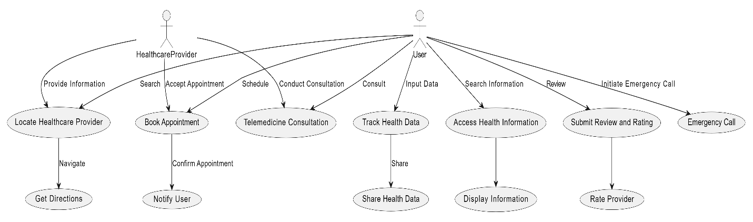

**4.2 Class Diagram**

The purpose of this diagram is to show how objects within the RHL system will interact

with each other in order to achieve the functionality required by the Use Case diagram.

Below is a list of what you will see in the diagram itself as well as the class descriptions

that follow.

|  |  |
| --- | --- |
| **User** | Represents app users, with attributes like userID and methods for searching providers and booking appointments. |
| **HealthcareProvider** | Represents healthcare providers, with attributes like providerID and methods for providing information and conducting consultations. |
| **Appointment** | Manages appointment data with attributes like appointmentID, user, and provider, and includes a method to confirm appointments. |
| **TelemedicineSession** | Handles telemedicine sessions with attributes like sessionID, user, and provider, and a method to initiate sessions. |
| **HealthData** | Manages health data entries with attributes like dataID and value, and a method to share data with providers. |
| **HealthInformation** | Represents health information with attributes like infoID and content, including a method to display information. |
| **ProviderInfo** | Contains information about healthcare providers with attributes like infoID and services, and a method to display provider information. |

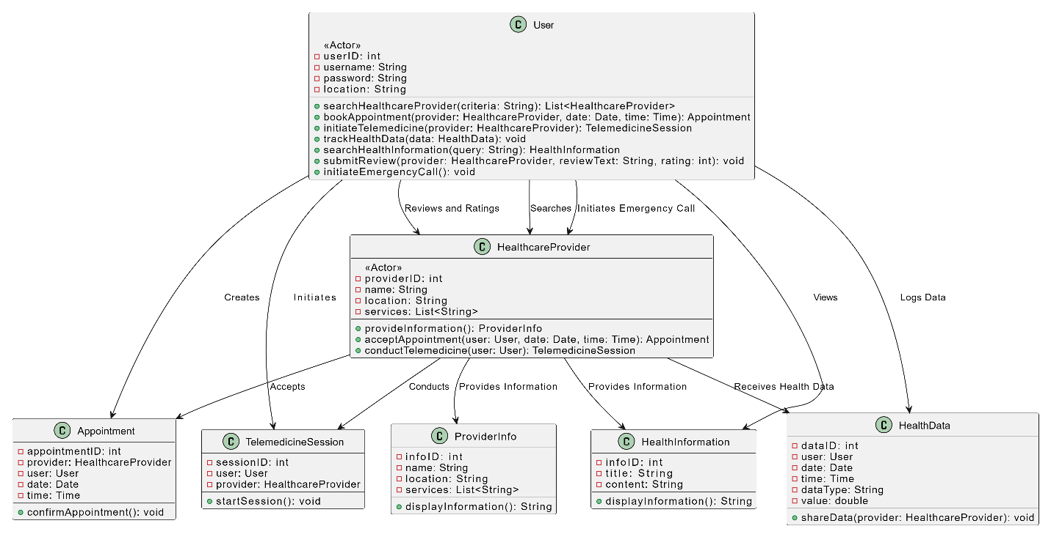

**4.3 Sequence Diagrams**

The sequence diagrams use the class diagram and demonstrate specific sequences of

actions in the system. The purpose is to ensure that the RHL system runs in an expected

way and that the class structure is sufficient to accomplish the tasks needed. Below is a

list of the items that you will see in the diagram and their definitions.

|  |  |
| --- | --- |
| **User Logs In** | The user initiates the login process to access the app's features. |
| **User Logs Out** | The user logs out of the app or ends a session. |
| **User Registers** | The user initiates the registration process to create a new account. |
| **User Selects "Book Appointment"** | The user chooses to book an appointment with a healthcare provider |
| **User Selects "Access Health Information"** | The user selects the option to access health-related information. |
| **User Initiates Appointment Booking** | The user starts the process of booking an appointment with a healthcare provider. |
| **User Initiates Telemedicine Consultation** | The user initiates a telemedicine session with a healthcare provider. |
| **User Logs Health Data** | The user inputs and logs their health-related data. |
| **User Submits a Review and Rating** | The user provides feedback and ratings for a healthcare provider. |
| **User Initiates an Emergency Call** | The user makes an emergency call for immediate assistance. |
| **User Searches for Healthcare Providers** | The user initiates a search for healthcare providers. |
| **User Views Provider Information** | The user views information about a healthcare provider. |
| **User Cancels Appointment Booking** | The user cancels the booking of an appointment with a healthcare provider. |
| **User Cancels Telemedicine Session** | The user cancels an ongoing telemedicine consultation. |
| **User Shares Health Data** | The user shares their health data with a healthcare provider. |
| **User Views Health Information** | The user accesses and views health-related information |
| **User Confirms Appointment** | The user confirms the booking of an appointment with a healthcare provider. |
| **User Confirms Telemedicine Session** | The user successfully confirms a telemedicine consultation. |
| **User Views Health Data** | The user views their health data shared with a healthcare provider. |
| **User Provides Review and Rating** | The user submits a review and rating for a healthcare provider. |
| **User Initiates Emergency Call from the App** | The user initiates an emergency call directly from the app. |
| **User Initiates Search for Healthcare Providers** | The user begins searching for healthcare providers within the app. |
| **User Views Provider Information from the App** | The user views healthcare provider information within the app. |
| **User Cancels Health Data Sharing** | The user cancels the sharing of their health data with a healthcare provider. |
| **User Views Health Information from the App** | The user accesses health-related information within the app. |

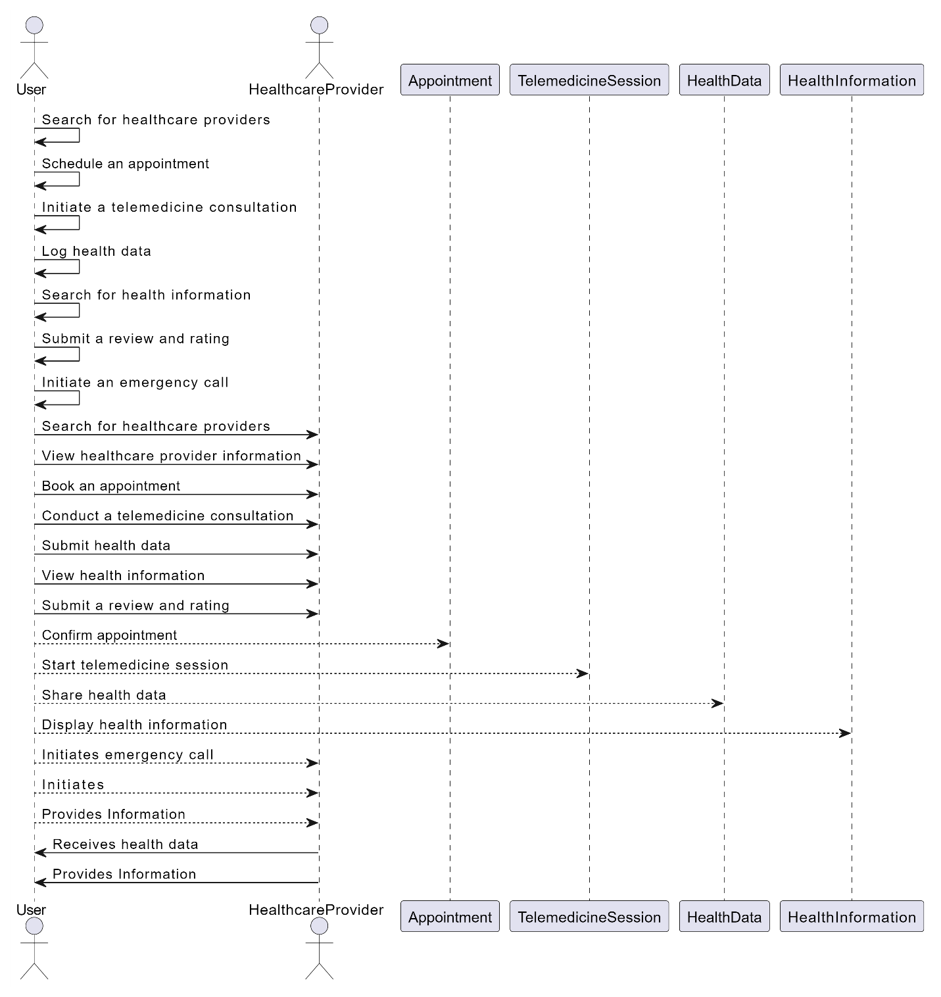

**4.4 State Diagrams**

The state diagrams take all of the functionality found in the previous diagrams and

combines them together to demonstrate the possible changes in the state within RHL.

These state diagrams contain all the possible scenarios shown in the sequence diagrams.

|  |  |
| --- | --- |
| **LoggedOut State** | Initial state where the user is logged out and can either log in or register. |
| **LoggingIn State** | Represents the user logging in, with transitions to the main menu upon successful login. |
| **Registering State** | Represents the user registering for a new account, with transitions to the login state upon successful registration. |
| **MainMenu State** | The main menu state where the user can access various app features, including booking appointments and accessing health information. |
| **Transition to BookingAppointment** | The user selects "Book Appointment" from the main menu, initiating the appointment booking process. |
| **Transition to AccessHealthInfo** | The user selects "Access Health Information" from the main menu, accessing health-related information. |
| **Transition to LoggedOut** | Represents the user logging out, ending the session, and returning to the logged-out state. |
| **Transition from LoggingIn to LoggedOut** | Represents a failed login attempt or user-initiated logout. |
| **Transition from Registering to LoggingIn** | The user successfully registers and is automatically logged in. |
| **Transition from Registering to LoggedOut** | The user cancels the registration process and returns to the logged-out state. |

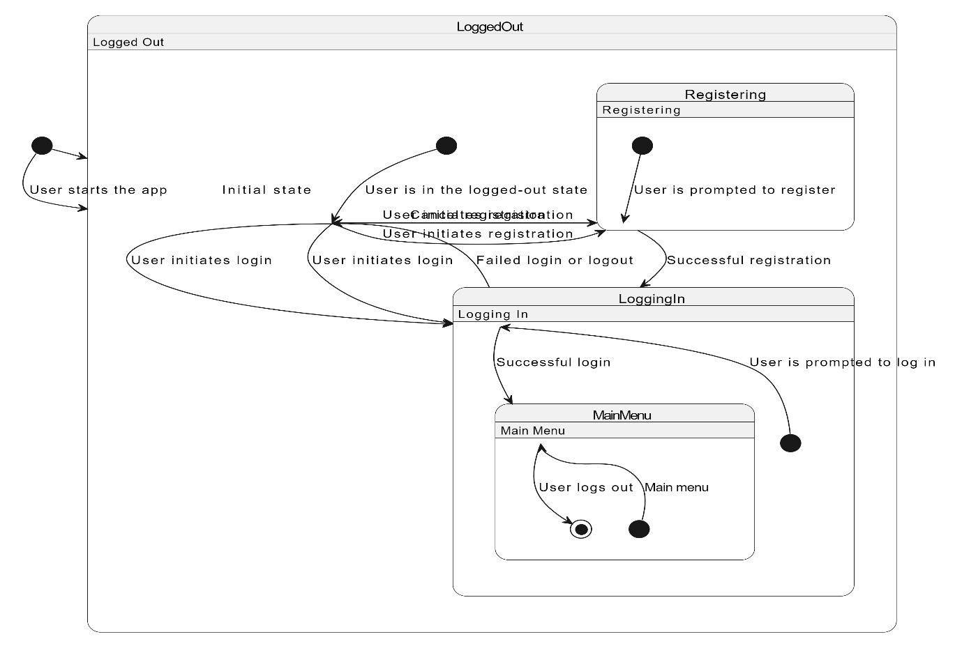

**6.Conclusion**

**The Rural Healthcare Locator App is a comprehensive solution to address the healthcare needs of rural Bangladesh. It provides essential features, such as locating healthcare providers, appointment booking, telemedicine, health data tracking, and health information dissemination. This SRS document outlines the requirements and functionalities necessary to develop the app successfully, improving healthcare accessibility and outcomes in rural areas.**

**7. References**

[1] <https://krazytech.com/projects>

[2] <https://www.perforce.com/blog/alm/how-write-software-requirements-specification-srs-document>

[3] <https://www.geeksforgeeks.org/>

[4] Fundamentals of SRS writing by Gate Smashers

**8 Point of Contact**

For further information regarding this document and project, please contact **Adib Hasan** and **Abdullah Al Mohimanul** (Student of DIU). All materials in this document have been sanitized for proprietary data. The students and the instructor gratefully acknowledge the participation of our industrial collaborators.